Chapter I
Introduction

  - Background of the Study

The concept of automated machines dates to antiquity with myths of mechanical beings brought to life. Before, the idea of making a machine capable of thinking and mimicking human functions and intelligence may be considered one of man’s fantasies.

With the advent of modern technology and the invention of microprocessors and microcontrollers, the once fantasy is now a reality. Having the aid of computer programming, it is now possible to integrate a set of commands or instructions to an electronic device to attain a specific purpose. Furthermore, by means of motors, gears and other electronic devices, creation of automated mechanical machine is possible.

Computer software nowadays are rapidly becoming more complex and advanced, implementing high level of programming logic and advanced analysis capability. With the introduction of Artificial Intelligence, computer programs are capable of performing tasks more complex than straightforward programming and sometimes have the ability to mimic human thinking capability, although still far from the realm of actual thought. Even though some computer systems already implement AI, but most are focused into software level only and does not have the mechanical components, an example of this software is a chess game application. At this aspect, the power of artificial intelligence is limited because it is only implemented at software level.

The research project’s heart is on how a machine or robot can interact with a human being replacing human senses and muscular function into electrical sensors and actuators with a high level of thinking that can match or even exceed human’s ability in a specific task under a managed environment. The proponents found the possible implementation or realization of this project through a chess robot Knight-S5 (K-S5) that have the mechanical components in which it is capable of playing chess game like a human chess player. Since chess is the most popular among board games and plays an important part in game and amusement and its tactical and strategical aspect, common people can easily relate and appreciate it aside from those who have technical knowledge like engineers and other experts in related fields. It implements the power of artificial intelligence to analyze complex chess movements on its own, has the ability to determine and process information based on human inputs through its sensors. It also has the ability to accept command in the form of human voice implementing speech-processing technology.

The purpose of this study is to create a chess robot which demonstrates human-machine interaction through artificial intelligence.
  - Statement of the Problem

1.2.1 General Problem

- Though some of present machines can mimic human activities or tasks, still some are limited to only basic and repetitive functions and cannot handle task that require analysis. Moreover, most of these automated machines use software programmed on low-level programming languages.
- Mostly, Artificial Intelligence is implemented only on computer software such that of an Expert System.

    - Specific Problems

- Chess games on computers are implemented only through software, no hardware.
- Game strategies, techniques and approach against a computer might be affected since the game mainly involves only the computer monitor (computer hardware).
- Playing with a high level thinking opponent is not always possible.

  - Objectives

    - General Objective

- To create a machine that can play conventional chess against a human player that can analyze, process chess movements on its own using artificial intelligence and move the chess pieces mechanically as if it was physically moved by human thus, will contribute in the development of integrating artificial intelligence on machines - enabling machines to interact with humans as well as playing the role of humans in some specific instances.

    - Specific Objectives

- To create an actuator with mechanical X, Y and Z components that would be able to perform valid chess move.
- To create a chess set with built-in board sensors that can detect specialized chess pieces.
- To create a microcontroller-based circuit that will control the actuator based on commands from the PC and that is able to feed data from sensors to PC synchronously.
- To create an application that will be based on a reliable programming language and application architecture which runs on modern operating systems that can manage the actuator and process data from sensors to coordinately work together, and translate chess commands from a chess engine into mechanical movements.
- To create a friendly environment that features easy to use user-interface and provide several means of communicating through the machine.
- To develop skills on microcontroller-based circuits, mechanical interfacing to the PC, data communication, other electronics theory and gain knowledge on modern software technologies.
- To develop a machine using low-cost materials and are available locally.

  - Hypothesis

- That K-S5 can imitate humans in playing the conventional chess game-both in thinking and moving the chess pieces mechanically.
- That K-S5 can contribute in the development of integrating artificial intelligence on machines.
- That K-S5 can help beginners learn chess easily.

  - Significance of the Study

Generally K-S5 contributes in the development of making machines capable of imitating human intelligence though K-S5 is implemented only on the game chess. It somehow exhibit the great power of machines (hardware) equipped with advance and intense software (AI). The K-S5 gives a picture of what role the future machines will play in interacting to human using artificial intelligence.

The concepts and theories covered in the development of the project may be adapted to other machines or devices for easier operation and human-like interaction – eliminating technicality. Other applications may be implemented in industrial aspects such as in manufacturing, fabrication, and other areas in which human skill can be substituted.

  - Scope and Delimitation

Even how powerful a machine maybe, all have their own limitations and proper operation will be altered if operated under unmanaged environment and operating procedures are not followed. The K-S5, if run under proper procedures expected output would be observed.

    - Scope

- The K-S5 has a mechanical arm, which is capable of picking and moving chess pieces.
- The K-S5 features built-in board sensors that can detect activities of chess pieces.
- The K-S5 is capable of sensing/determining presence of chess piece and its location with respect to the chessboard using its sensor in the mechanical arm.
- The K-S5 can determine whether commands or moves from humans are valid, otherwise it will notify the user though an indicator.
- The K-S5 can accept inputs through speech recognition (voice command).
- The K-S5 can interact with the user through computer speech.
- The K-S5 can think independently against human where level of difficulty can be adjusted.
- The K-S5 has a constant level of thinking.

    - Limitation

- Once a single piece was removed from the chess set, the K-S5 can determine it but can’t make any further actions.
- In starting the game, chess pieces must be arranged to its default position because the K-S5 can’t distinguish one chess piece to another physically.
- A chess piece must be placed close to the center of the square for it to be detected by the board sensor.
- Interrupting the actuator while in operation may affect the accuracy and performance of the machine.

Definition of Terms

Actuator – A power mechanism used to initiate motion of the robot (eg. a motor which converts electrical, hydraulic, or pneumatic energy to movement of the robot).

Ampere – SI unit of electric current: the basic unit of electric current in the SI system, equal to a current that produces a force of 2x10\endash 7 newtons per meter between two parallel conductors in a vacuum.

Architecture – computing structure of computer system: the design, structure, and behavior of a computer system, microprocessor, or system program, including the characteristics of individual components and how they interact.

Artificial Intelligence (AI) – a term that in its broadest sense would indicate the ability of an artifact to perform the same kinds of functions that characterize human thought.

AXIS – A direction used to specify the robot motion in a linear or rotary mode.

Breadboard – a preliminary version of an electrical or electronic circuit put together for test purposes

Capacitor – an electrical component, used to store a charge temporarily, consisting of two conducting surfaces separated by a nonconductor (dielectric).

Chopper – electrical engineering interrupting device: a device that regularly interrupts an electric current, a beam of light, or some other stream of radiation in order to produce a pulsing flow or beam.

Conventional Chess – game of skill between two people that is played using specially designed pieces on a square board comprised of 64 alternating light and dark squares in eight rows of eight squares each.

Current – the flow of electricity through a cable, wire, or other conductor.

Diode – an electronic device that has two electrodes and is used to convert alternating current to direct current. More reliable semiconductor devices have replaced the older vacuum tube diodes.

Electromagnet – a magnet consisting of a core, often made of soft iron that is temporarily magnetized by an electric current in a coil that surrounds it.

End-Effector – An accessory device or tool specifically designed for attachment to the robot wrist or tool mounting plate to enable the robot to perform its intended task (e.g. gripper, spot welding gun, spray gun, etc).

Gear – a lever or mechanism in a car or other vehicle or machine that is used to shift or engage gears.

Human-Machine Interaction – denotes the interaction of a human being and a specific task and environment between a machine (robot) that uses artificial intelligence imitating human functions through sensors and actuators.

I/O – The input and/or output signal.

Integrated Circuit (IC) – an extremely small complex of electronic components contained on a thin chip or wafer of semiconducting material such as silicon.

K-S5 (Knight-S5) – name of the prototype of the project.

Laser – a device that utilizes the ability of certain substances to absorb electromagnetic energy and re-radiate it as a highly focused beam of synchronized single-wavelength radiation.

LPT (Parallel Port) – a connection point through which a computer sends and receives data simultaneously by means of a number of separate wires, commonly used for connecting a printer or external storage device. Computers transmit data through the parallel port at higher speeds and with fewer errors than through the serial port.

Microprocessor – the central processing unit that performs the basic operations in a microcomputer. It consists of an integrated circuit contained on a single chip.

Motion Space – The range in which the robot can operate.

Multitasking – The state in which multiple programs are executed virtually simultaneously. It is realized in the way that CPU of the robot controller executes each program in a short interval by turns.

Ohm – unit of electrical resistance: the SI unit of electrical resistance, equal to the resistance between two points on a conductor when a potential difference of 1 volt produces a current of 1 ampere.

Ohm’s Law – the law of physics that states that electric current is directly proportional to the voltage applied to a conductor and inversely proportional to that conductor’s resistance.

Power Transistor – a transistor that gives a high power gain, typically dissipating from 1 to 100 watts and usually requiring some form of cooling.

Printed Circuit Board (PCB) – an electronic circuit in which some components and the connections between them are formed by etching a metallic coating on one or both sides of an insulating board.

Resistor – a component of an electrical circuit that has resistance and is used to control the flow of electric current.

Rotor – rotating part of machine: a rotating part of an electrical apparatus, for example, the armature of a generator, or of a mechanical device.
Sensor – a device capable of detecting and responding to physical stimuli such as movement, light, or heat.

Speech Recognition (Voice Command) – the ability of a computer to understand the spoken word for the purpose of receiving commands and data input from the microphone.

Speech Synthesis – computer-generated audio output that resembles human speech.

Stepper Motor – an electric motor with a rotor that can be moved to various fixed angles, used for rotating and positioning components or other items.

Torque – mechanical engineering ability to overcome resistance: the measurement of the ability of a rotating gear or shaft to overcome turning resistance.

Transistor – a small low-powered solid-state electronic device consisting of a semiconductor and at least three electrodes used as an amplifier and rectifier and frequently incorporated into integrated circuit chips.

Voltage – electric potential expressed in volts.

Volts – the unit of electromotive force and electric potential difference equal to the difference between two points in a circuit carrying one ampere of current and dissipating one watt of power.

Conceptual Framework

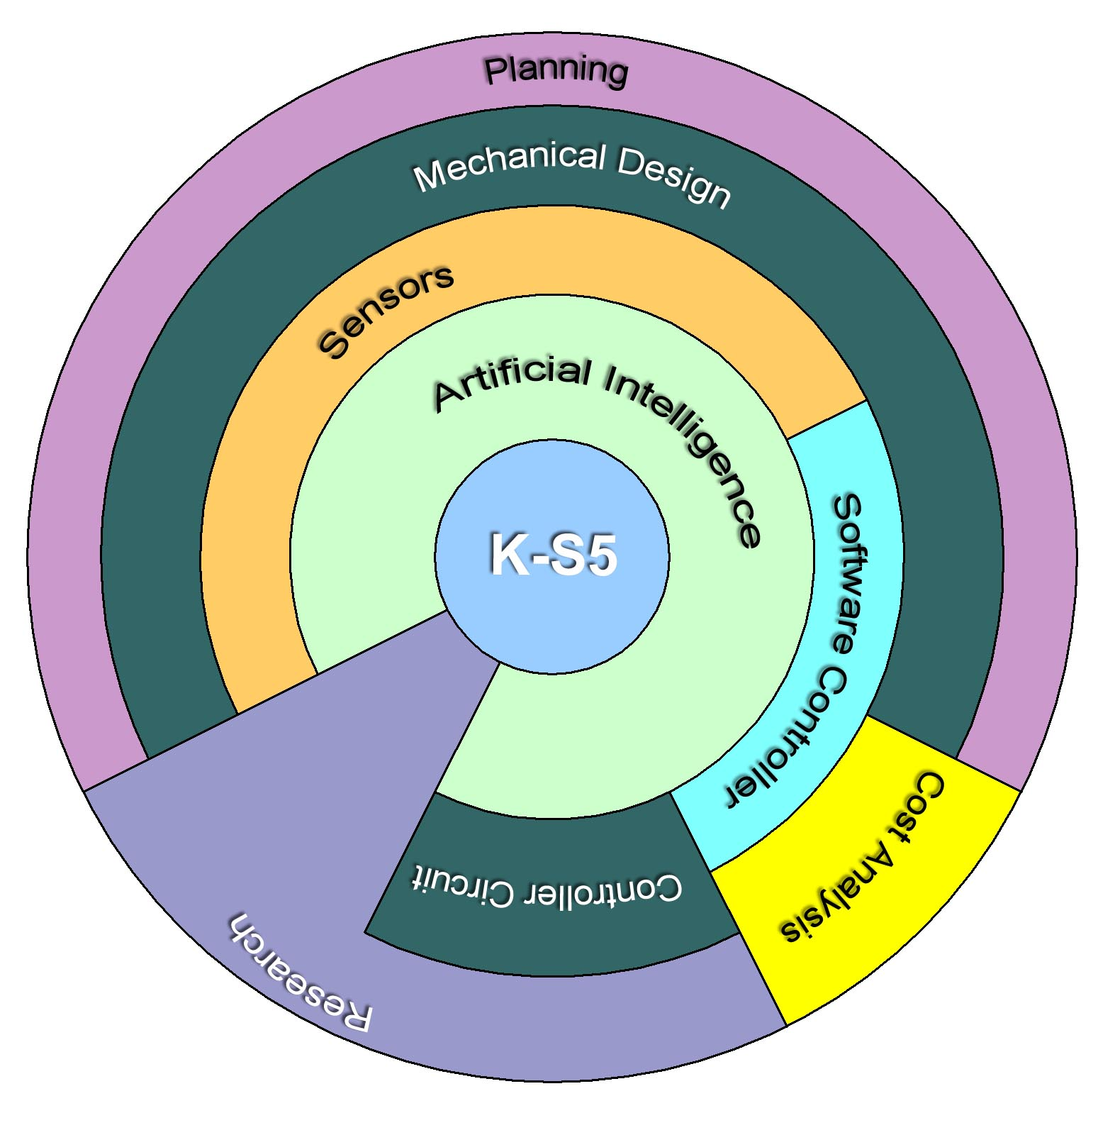
Fig 1.1 Conceptual framework of the K-S5 development

Primary steps in the development of the K-S5 involve planning, research and cost analysis as shown in the framework above. Planning actually concerns all the probable concepts and materials that would be used throughout the completion of the project. Research will play an important role almost all through in every part of the project since it will provide the proponents sufficient knowledge necessary to complete the project. Cost analysis will somehow give the proponents an idea of how much it would cost, hence, determine the economic feasibility of the machine. The Mechanical Design concerns the design and construction of the hardware components including the Controller Circuit, which is responsible for interfacing the mechanical part to the computer. Other components are the Sensors, detecting instrument, attached together with other hardware to the Software Controller, which is responsible for control, accuracy and precision of the hardware. Of course, to provide the machine thinking ability is the Artificial Intelligence. All this stuff put together yields the expected output – K-S5.

